EXPERIMENT NO. 8
GAS SENSOR MQ-2 IN PROTEUS USING ARDUINO
AIM:
To write an Embedded C program for interfacing Gas Sensor MQ-2 using Arduino Uno and Proteus.
SOFTWARE REQUIRED:
- Proteus 8 Professional
- Arduino IDE
ALGORITHM:
1. Configure the MQ-2 analog input and LED output.
2. Read the analog sensor value using analogRead().
3. Print the sensor value through serial communication.
4. If the value is above the threshold, turn the LED ON; otherwise turn it OFF.
5. Repeat continuously.
PROGRAM:
#define GreenLed 13
#define Sensor A0
void setup(){
pinMode(13, OUTPUT);
pinMode(12, OUTPUT);
pinMode(A0, INPUT);
Serial.begin(9600);
}
void loop(){
int value = analogRead(A0);
Serial.print("Analog Value coming from the sensor : ");
Serial.println(value);
delay(100);
if(value > 600)
digitalWrite(13, HIGH);
else
digitalWrite(13, LOW);
delay(20);
}
OUTPUT:
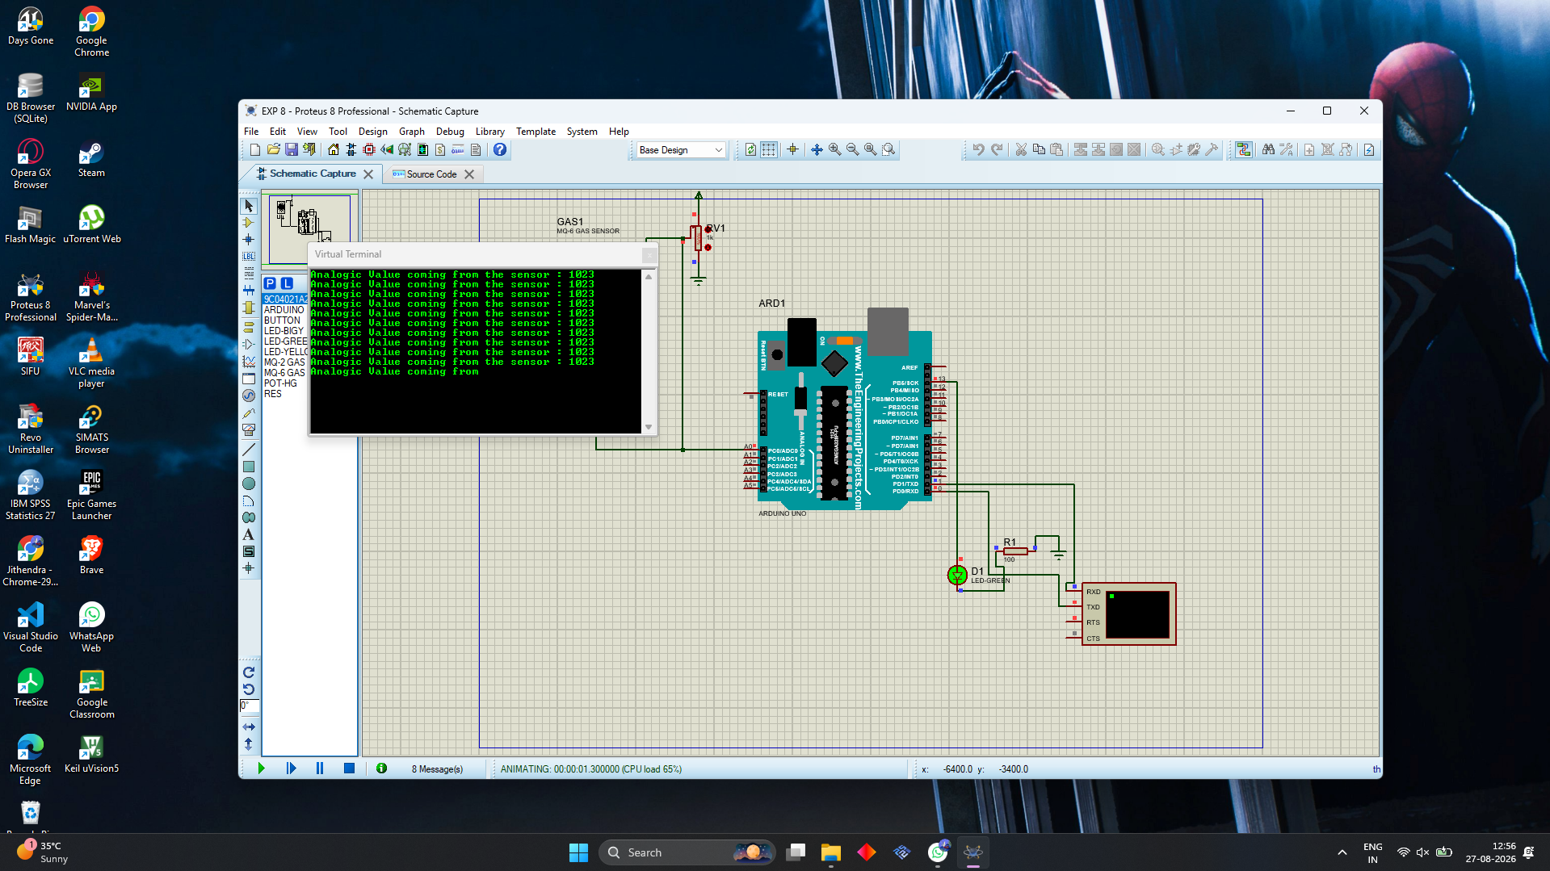
Output reference image supplied for this experiment.
OBSERVATION:
The sensor value is displayed through the Virtual Terminal. When the value exceeds the threshold, the LED is turned ON.
RESULT:
Thus, the program has been successfully verified and executed.

